**AI BASED DIABETES PREDICTION SYSTEM**

**PHASE_3**

Developing the diabetes prediction system by preparing the data and selecting relevant features.

**INTRODUCTION**:

In the exciting journey of building your project, a crucial foundation is laid during the initial phase, where we focus on loading and preprocessing the dataset. This pivotal step marks the inception of our diabetes prediction system development. As we embark on this data-driven adventure, our primary goal is to meticulously prepare the data, ensuring its quality and consistency. We will also delve into the critical task of feature selection, identifying the most relevant attributes that will empower our predictive model. Through this meticulous process, we set the stage for a robust and accurate diabetes prediction system, ready to make a positive impact on healthcare and patient well-being.

IMPORTING LIBRARIES FOR DATA PROCESSING

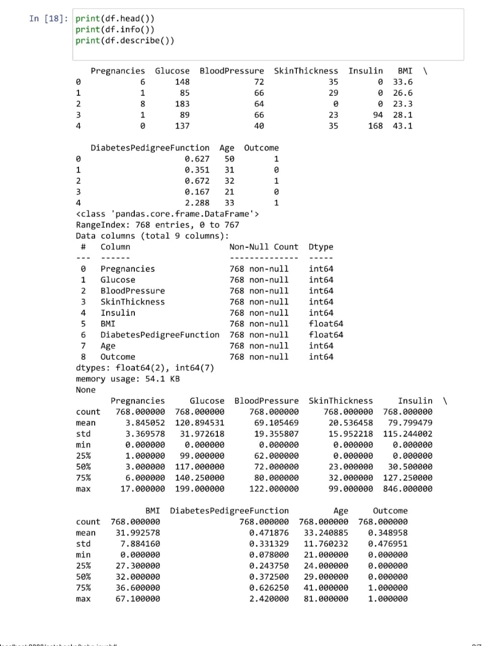

PLOTING DATA

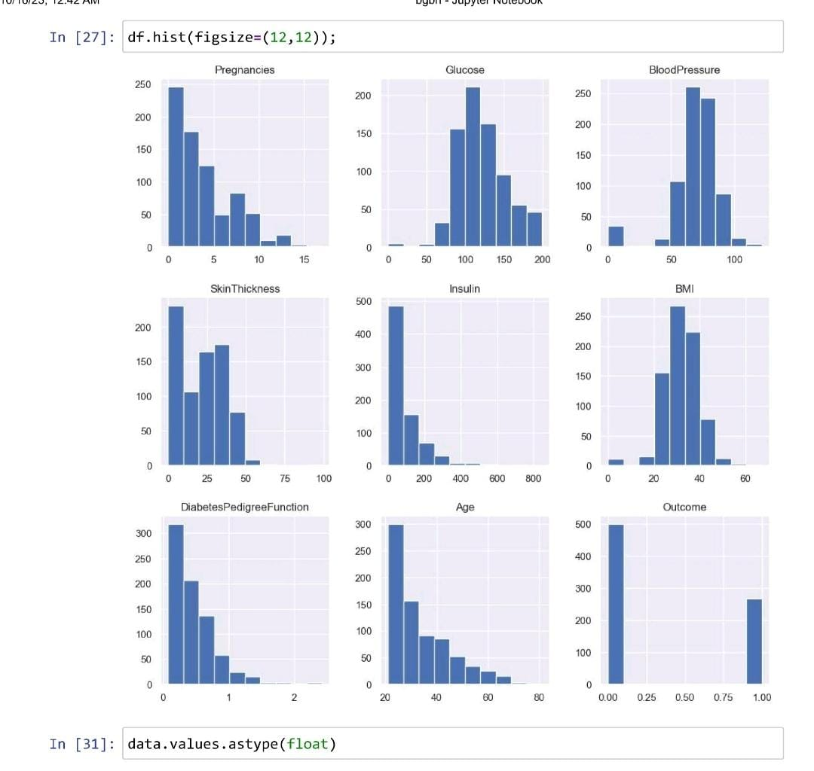

**CONCLUSION:**

In conclusion, the successful execution of the data loading and preprocessing phase sets a solid groundwork for our diabetes prediction project. This marks a promising start in our journey towards developing an impactful diabetes prediction system.